Review Topics

1. Gradient Properties:
=>Linear gradient:
(why not background-color? = because background-color only accepts solid color and rgba and gradient color is classsified as image data type rather than color. If you use background-color, browser ignore the property)
-> Top to bottom :
#grad{
background-image: linear-gradient(to bottom, red, yellow);
}
<div class=”bg-gradient-to-b from-red to-yellow”>
-> Bottom to top :
#grad{
background-image: linear-gradient(to top, red, yellow);
}
<div class=”bg-gradient-to-t from-red to-yellow”>
-> Left to right :
#grad{
background-image: linear-gradient(to right, red, yellow);
}
<div class=”bg-gradient-to-r from-red to-yellow”>
-> Diagonal:
#grad{
background-image: linear-gradient(to bottom right, red, yellow);
}
<div class=”bg-gradient-to-br from-red to-yellow”>
->Linear gradient using angles:
- 0 degree = to top
- 90 degree = to right
- 180 degree = to bottom
- 270 degree = to left
background-image: linear-gradient(angle, color1, color2);
->multiple color:(top to bottom)
#grad{
background-image: linear-gradient(green, red, yellow);
}
#grad{
background-image: linear-gradient(to right, green, red, yellow, multiple-color...);
}
->Repeating linear gradient function:
#grad{
background-image: repeating-linear-gradient(red, yellow 10%, green 20%);
}

=> Radial gradient:
- color transition that goes out from a central point.
background-image: radial-gradient(shape size at position, start-color, ..., last-color);

->Evenly spaced color spots:
#grad{
background-image: radial-gradient(green, red, yellow);
}
->Differently spaced color spots:
#grad{
background-image: radial-gradient(green 5%, red 15%, yellow 60%);
}
-> Set shape:
- Ellips – by default
- circle
#grad{
background-image: radial-gradient(circle, red, yellow, green);
}
-> The size parameter:
- closest-side: The circle expands until it touches the nearest wall (edge) of the box. This creates the smallest possible circle.
- Farthest-side: The circle expands until it touches the furthest wall (edge) of the box.
- Closest-corner: The circle expands until it touches the nearest corner vertex of the box.
- Farthest-corner: The circle expands until it touches the furthest corner vertex of the box. This creates the largest possible circle

#grad{
background-image: radial-gradient(closest-side at 70% 60%, red, yellow, black);
}
#grad2{
background-image: radial-gradient(farthest-side at 70% 60%, red, yellow, black);
}
-> Repeating radial parameter:
#grad{
background-image: repeating-radial-gradient(red, yellow 10%, green 15%);
}
(reb blend into yellow untill it not become pure yellow at 10% and yellow blend into green untill its not become pure green at 15%)
- first loop: 0% to 15% (red -> yellow -> green)
- 2nd loop: 15% to 30% (red -> yellow -> green)

=> Conic Gradients:
- A conic gradient is a gradient with color transitions rotated around a center point. (at least 2 color required. By default degree=0, position=center)
background-image: conic-gradient( [from angle] [at position], color [degree], color [degree]);

#grad{
background-image: conic-gradient(red 45deg, yellow 90deg, green 210deg);
}
- 0 – 45 = red
- 45 – 90 = yellow (pure yellow at 90)
- 90 – 210 = green
- remaining = for remaining browser feel the last color
-> Pie chart:

#grad {
background-image: conic-gradient(red, yellow, green, blue, black);
border-radius: 50%;
}
-> conic radial specified with angle:(it start from the angle which is specified)
#grad{
background-image: conic-gradient(from 90deg, red, yellow, green);
}
red color start form 90 degree.
-> specified position:
#grad{
background-image: conic-gradient(at 60% 45%, yellow 90deg, green 210deg);
}
center point is at 60 45 %.
-> repeating conic gradient:
#grad{
background-image: repeating-conic-gradient(red 10% green 20%);
}

Source Link: https://www.w3schools.com/css/css3_gradients.asp

2. How to manage dark and light theme css in single page?
- We can use symantic token system for managing theme variables in one file.
- In global.css
@theme {
// Default Light Theme
--color-bg-main: #f9fafb; /* Page background */
--color-bg-card: #ffffff; /* Card component background */
--color-text-main: #111827; /* Main text color */
--color-text-muted: #4b5563; /* Secondary text / descriptions */
--color-accent: #ef4444; /* Your main theme color (e.g., Red) */
}

@variant dark (&:where(.dark, .dark *)) {
/* --- Dark Theme Overrides --- */
--color-bg-main: #0f172a; /* Dark background */
--color-bg-card: #1e293b; /* Dark card background */
--color-text-main: #f9fafb; /* Light text */
--color-text-muted: #9ca3af; /* Dimmed text */
--color-accent: #3b82f6; /* Accent switches from Red to Blue in dark mode! */
}
- and then we can simply use it in class of div like,
<div class="bg-bg-main text-text-main min-h-screen p-8">
<div class="bg-bg-card p-6 rounded-lg shadow">
<h2 class="text-xl font-bold">Card Component</h2>
<p class="text-text-muted">This text uses the muted gray color scheme.</p>
<button class="bg-accent text-white px-4 py-2 mt-4 rounded">Accent Button</button>
</div>

<div class="bg-bg-card border-l-4 border-accent p-4 mt-6">
<p class="text-text-main font-semibold">Important Notification</p>
<p class="text-text-muted text-sm">Automatically styled using your central theme config.</p>
</div>
</div>
Source Link : I have search this solution from google

3. Departmrent filter with API:
- Create a state for the department list or the selected department.
- Create a state for the fetched data items.
- Pass the selected department as a query parameter in your API call.
- Steps:
  - fetch url of filter
  - store the data and use if this data as setData useState which is manage for showing the data on the browser.
- It will not override the data:
  - because React completely replaces the state array every time the API response arrives. (use useEffect)

Source Link : I have search this solution from google

4. Alternative of alert box:
Source : I have search this different method from google
- Sonner library
  - use Toaster:
    - import : import { Toaster, toast } from 'sonner';
    - <Toaster position="top-center" richColors />
    - (richColors = change the color of the box based on intent – success, error, warning)
    - then use in the button: onClick() => toast.success(“added..”)
    - Source : https://www.npmjs.com/package/sonner
- Built-In: Native HTML5 <dialog> with react ref:
  - use .showModal method for opening the alert box
  - use .close methos for closing the alert box
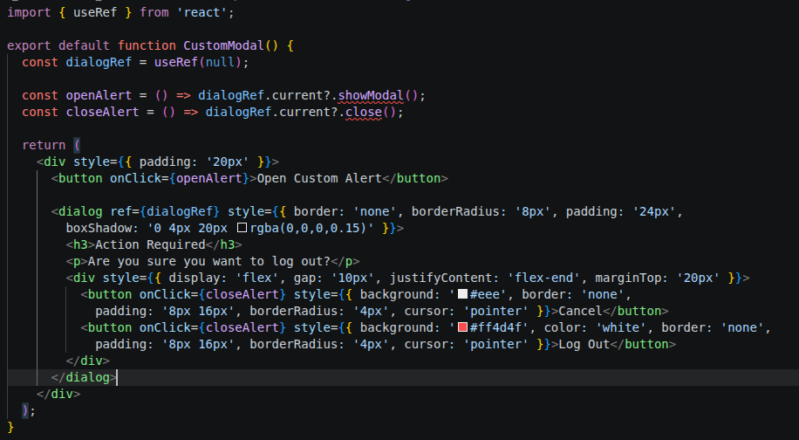
  - Why use useRef?
    - we use useRef because we need to call built-in, native browser methods (.showModal() and .close()) directly on the HTML element.
- Make your own component
- Can use UI framework integration by:
  - npx shadcn@latest add alert-dialog
    - AlertDialog, AlertDialogAction, AlertDialogCancel, AlertDialogContent, AlertDialogDescription, AlertDialogFooter, AlertDialogHeader, AlertDialogTitle, AlertDialogTrigger,
    - and then can simply use this by using like a tag
    - Source : https://ui.shadcn.com/docs/installation/vite
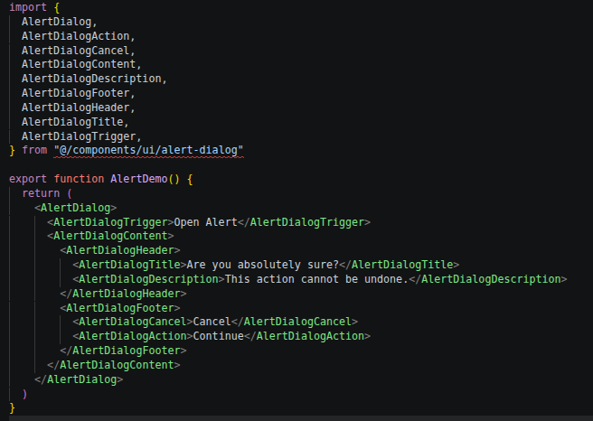
5.Handle multiple delete of user:
- make a checklist in front the row of each user
- create a state and function to manage selectedId (selectedUser) of user
- make a function that contain the ids of selected use
- make a delete function
- Source : Search this solution google

6. Multiple column in one table:
- we can make button at top of the table for left moving and right moving and shows different colums of table
- we can also use mouse effects – drag to scroll option, we can move the columns by draging through mouse
- Source : Search this solution google

7. When using async function, necessary to write Promise or not:
- No, it is not necessary to write the Promise keyword when we use async and await
- The async keyword automatically transforms function so that it implicitly returns a Promise, meaning JavaScript wraps return value in a Promise behind the scenes
- When it is not necessary:
  - when we are working with the modern api keys or fetch the api that already return a Promise.
  - We have to write new Promise() when promisifying an older, callback-based API (like setTimeout or Node.js fs.readFile) that does not natively support async/await
  - Source : Search this solution from google
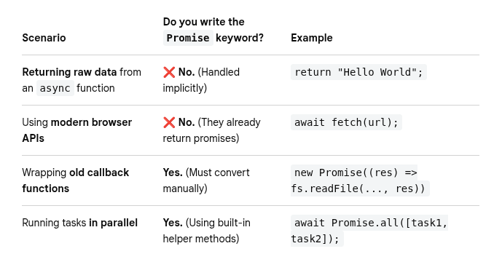
8. 8. 8.Alternative of table:
- can use card layouts
  - cards break row data into individual visual container
  - looks beautiful and different
  - best for: user profile, portfolio, blog posts, e-commerce products
- Kanban board
  - if data item is moving through different stages or statuses, kanboard is turning boring rows into interactive columns
  - best for: task management, project tracking, sales pipelines
  - Source : Just show and explore this design from https://www.atlassian.com/software/jira/templates/kanban
- Source : Search this solution google

9. Grid properties:
- specifying gris cols:
  - grid-cols-<number>
- implementing subgrid:
  - use grid-cols-subgrid to adopt the column tracks define by the item’s parent
  - it is a nested grid.
  - If we use this, it generate like nested grid of main parent grid.
  - With the use of sybgrid, it use the structure of main parent grid instead of generating its own new grid structure
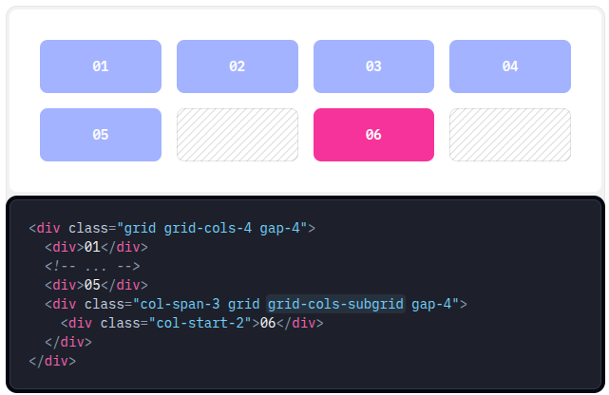

- responsive design:
  - <div class=”grid grid-cols-2 md:grid-cols-3”>
- if want to merge div then use col-span property
<div class=”grid grid-cols-6”>
<div></div>
<div></div>
<div></div>
<div class=’’col-span-2”></div>
<div></div>
</div>
- starting & ending lines
<div class="grid grid-cols-6 gap-4">
<div class="col-span-4 col-start-2 ...">01</div>
<div class="col-start-1 col-end-3 ...">02</div>
<div class="col-span-2 col-end-7 ...">03</div>
<div class="col-start-1 col-end-7 ...">04</div>
</div>

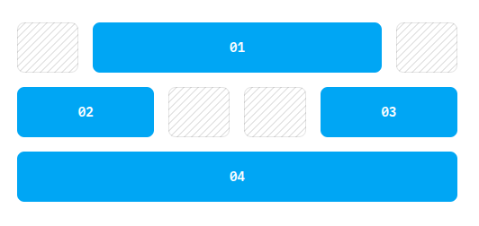

- Grid rows:
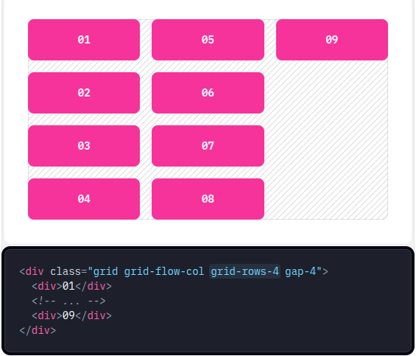

- (instructs it to flow vertically by columns (grid-flow-col))
- (same property used for cols are used for rows also)
- Source: https://www.w3schools.com/css/css_grid.asp

10. Form handling libraries:
- Source: Search this different method from google
- React Hook Form:
  - When to use: Your default choice for standard to highly complex web apps using React or Next.js, especially when performance is a priority.
  - For what: Large, heavy forms (e.g., multi-step checkouts, long dashboards) where you want to avoid UI lag caused by constant re-renders.
  - However, some users find RHF less suitable for extensive forms, and there have been remarks about it being too “verbose.”
  - Source : https://react-hook-form.com/
- TanStack form:
  - When to use: building an enterprise-level TypeScript application where absolute type safety is non-negotiable.
  - For what: Complex, nested, or dynamically generated form fields where TypeScript must catch typos or wrong data types during compilation.
- Formik:
  - When to use: You are maintaining a legacy codebase or working with highly structured, traditional React setups.
  - For what: Smaller forms where absolute performance efficiency isn't a bottleneck.
  - Source : https://formik.org/docs/tutorial
- Conform:
  - When to use: When you are using modern full-stack framework and want more user accessibility and server rendering.
  - For what: Building forms that support Progressive Enhancement, meaning the form fully submits and handles server validation errors even if the user's browser has slow internet or disabled JavaScript.

11. Reduce multiple if statement in validation:
- We can make a array instead of multiple if statements.
- We can map the validation constraints to a configuration array
- We can also use schema validation library like zod or Yup.
- Source : Search this solution from google

12. Shadcn library:
- Shadcn/ui is a collection of re-usable, accessible components that you copy and paste directly into your project rather than installing as a traditional node package.
- Instead of forcing you to download a giant, locked npm package, shadcn/ui builds an open-code architecture directly inside your project folder.
- Source : https://ui.shadcn.com/docs/installation/vite

13. Query Params:
- Query parameters are optional key-value pairs added to the end of a URL to send extra information to a server.
- They help filter, sort, or paginate data without changing the main web address or endpoint.
- Structure: The params always start with ? After the url path.
- Key and value: each parameter uses key=value fromat, joined by equal sign.
- Multiple values: multiple paramete are separated by ampersand sign &.
- Query parameters are important because they allow a single web page to display millions of different variations of data dynamically.
- By using query params, The website doesn't need to load a whole new page layout just because you changed a filter. It just swaps out the data.
- Source : Seach this from goole

14. List view vs Table view:
- Table View is ideal when users must compare attributes across multiple items, sort columns, or scan dense structured data. A List View is better when users mainly read down a single stream and only a few key attributes matter per item.
- Source : Seach this solution from goole

